**ELEC-E7250 - Laboratory Course in Communications Engineering**

Preliminary exercises: Linear time-variant channel

Group members: Xingji Chen and Zheyuan Liu

1. How can you generate a 2-tone signal centered at *fc* = 400MHz and having frequencies *fl* = 395MHz and *fh* = 405MHz, given that you have an arbitrary waveform generator (AWG) an IQ modulator at your disposal. AWG can generate any waveform whose maximum frequency is less than 100 MHz. How can you generate M-tone signal, where M can be M = 2, 4, 5, ...

First, we need to generate two sine waves whose frequencies correspond to the offsets from the carrier frequency. Since the carrier frequency *fc* is 400 MHz, the lower frequency *fl* is 5 MHz below the carrier, and the higher frequency *fh* is 5 MHz above the carrier. Therefore, two sine waves should be generated at 5 MHz and -5 MHz (or 5 MHz for a positive frequency representation in baseband).

An IQ modulator can shift the baseband signals to the desired carrier frequency. The modulator uses two mixers to process the in-phase (I) and quadrature (Q) components separately, which are combined to modulate the baseband signal onto the carrier frequency. By feeding the generated baseband signals into the IQ modulator and setting the carrier frequency to 400 MHz, we can obtain the desired two-tone signal centered at 400 MHz, with components located at 395 MHz and 405 MHz.

To generate an M-tone signal (where M could be 2, 4, 5, etc.), we can adopt a similar approach but generate more baseband sine waves corresponding to each tone's frequency offset. For example, if M = 4 and there is a desire for tones at offsets of -10 MHz, -5 MHz, 5 MHz, and 10 MHz, the AWG would be used to generate four sine waves at these frequencies. Then, all the generated baseband sine waves would be fed into the IQ modulator, setting the carrier frequency to the required center frequency.

1. Rayleigh probability density function *f* (*r*) is the amplitude distribution of a complex Gaussian signal.



where *u*(*r*) is the unit step function.

1. Present the complex signal *X* + *j · Y* in polar form *r · ejθ*. How can you interpret *r* and *θ* ?
2. If the random variables *X* and *Y* are independent and have zero-mean Gaussian distribution with the same variance *σ*2 (this is ”complex Guassian”). Write out the joint probability density function *f* (*x*, *y*)?
3. Do a change of variables *X* = *r* cos(*θ*) and *Y* = *r* sin(*θ*) and derive from *f* (*x*, *y*) *f* (*r*, *θ*). This is the joint distribution of the amplitude and phase of a complex Gaussian signal at the given time instant.
4. Find the Rayleigh pdf *f* (*r*) by integrating 0 ≤ *θ* < 2π away from *f* (*r*, *θ*). What is the pdf of the phase, i.e. *f* (*θ*)?
5. How can the assumption that *X* and *Y* are Gaussian be justiﬁed in a multipath fading scenario?
6. Comment only: What distribution would *f* (*r*) be if *X* and *Y* are not zero-mean (but still independent Gaussians)?
7. The magnitude *r* represents the amplitude of the complex signal and is calculated as the square root of the sum of the squares of *X* and *Y*:



This magnitude *r* is a random variable that follows the Rayleigh distribution as described by the probability density function (PDF) given in the question. The magnitude *r* quantifies the overall signal strength.

The phase *θ* represents the angle of the complex signal with respect to the real axis and is calculated using the arctangent of *Y* over *X*, considering the signs of *X* and *Y* to determine the correct quadrant:



This phase *θ* tells us the direction of the vector representing the complex signal in the complex plane. The phase indicates how much the signal waveform is shifted in time or phase-shifted with respect to a reference signal.

1. For independent random variables *X* and *Y*, both having a zero-mean Gaussian distribution with the same variance *σ*2, the joint probability density function (PDF) *f* (*x*,*y*) of *X* and *Y* (representing a complex Gaussian distribution when considered together) can be written as the product of their individual PDFs, due to their independence.



1. Given:



Substituting them into *f* (*x*,*y*), we have:



To complete the transformation, we calculate the Jacobian determinant of the transformation from (*x*,*y*) to (*r*,*θ*):



Therefore, the transformed joint PDF *f* (*r*,*θ*) is given by:



1. Integrating over *θ* gives us the marginal pdf for *r*:



To find the pdf of the phase *θ*, *f* (*θ*), we observe that the phase *θ* is uniformly distributed from 0 to 2*π* because the joint pdf *f* (*r*,*θ*) does not depend on *θ* (other than through the integration limits). Therefore, the pdf of *θ* is:



1. In a multipath fading environment, the transmitted signal reaches the receiver through multiple paths. These paths are subject to variation due to reflections, diffractions, and scatterings caused by obstacles such as buildings, trees, and vehicles. The signal components that travel along different paths may have varying amplitudes, phases, and delays. When these components combine at the receiver, the resulting signal can exhibit significant variations in amplitude and phase over time and frequency, a phenomenon known as fading.

The Central Limit Theorem states that the sum of a large number of independent random variables, each with a finite mean and variance, tends towards a normal distribution, regardless of the original distribution of the variables. In the context of multipath fading, the received signal is the sum of many small contributions from the multitude of paths. Due to the randomness in path lengths, scattering mechanisms, and the relative phases of the signals, the contribution of each path can be considered a random variable. The in-phase and quadrature components of the received signal result from the summation of the respective components of all the multipath signals. Given the large number of paths and the random variations in their contributions, the CLT implies that due to the aggregation of a large number of small, independent effects, *X* and *Y* tend towards Gaussian distributions.

1. Rician distribution.
2. Assume a two tap channel with independently Rayleigh fading taps. *τ*0 = 0 and *τ*1 = 200 ns. After correlation in *τ* direction this channel has impulse response



where *α*0, *α*1 are Rayleigh fading amplitudes of the taps and *δ* (.) is Dirac delta function.



where average amplitudes are equal .

1. Derive the space frequency correlation function .
2. Derive amplitude of the space frequency correlation function as .
3. Plot the function for frequency interval 0 . . . 5 MHz.
4. Fourier transform



1. Using Euler's formula



The amplitude is



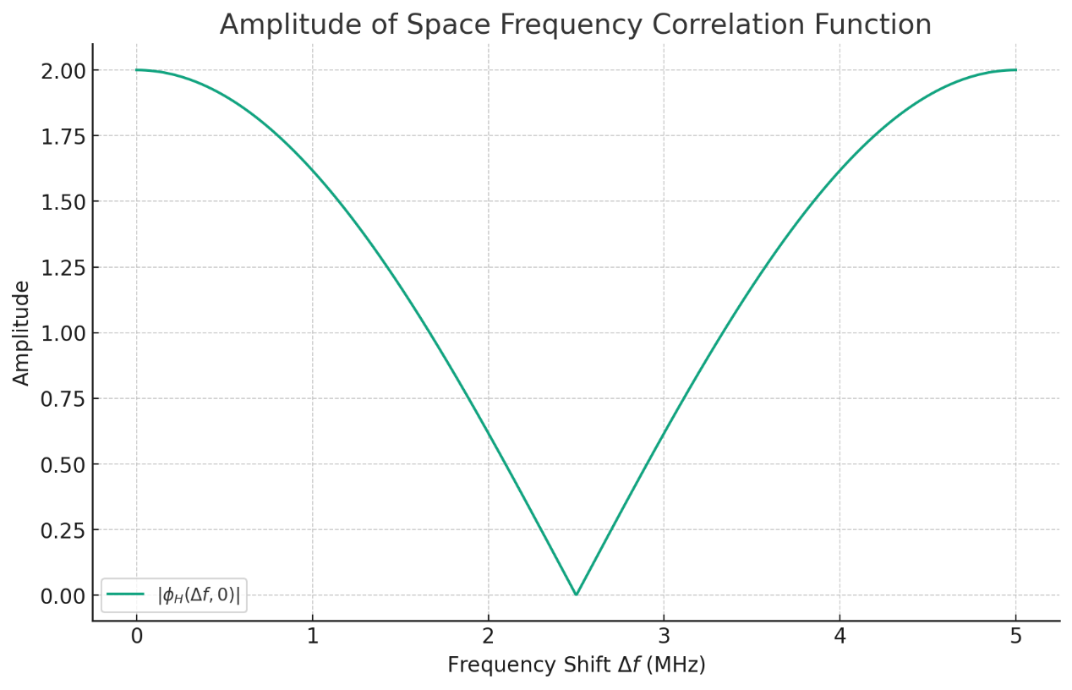

1. A linear time-variant (LTV) system is described by correlation of its impulse response correlation function



where parameter *n* = 4*m*. Compute and sketch the following functions:

1. The function itself . (Set *τ* to be on *x* axis and *t* on *y* axis and the amplitude ** on *z* axis).
2. The frequency response  that is Fourier transform of the function with respect to *τ*. (for that take Fourier transform with respect to *τ* and assume that *t* is constant).
3. Since *n*=4*m*, the expression simplifies to:



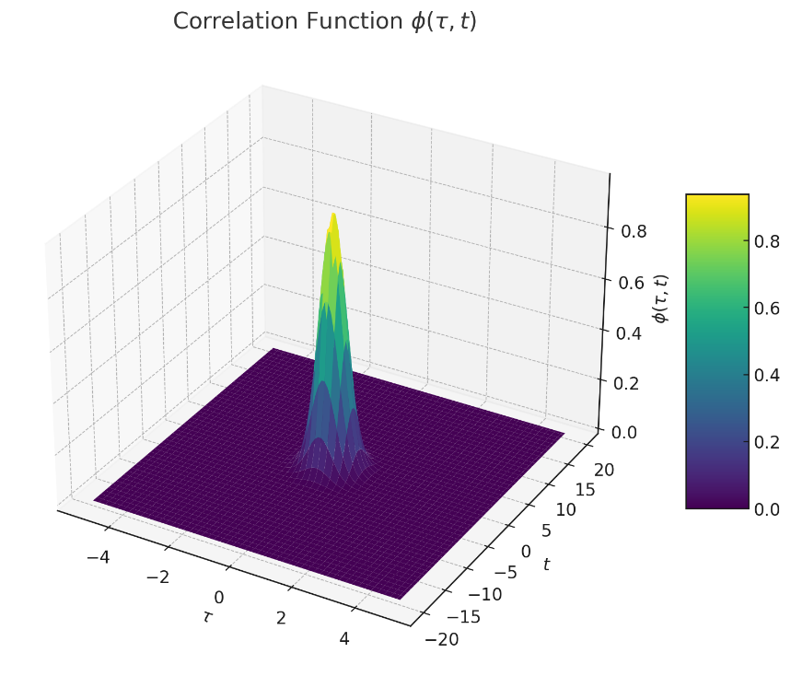

1. The Fourier transform of a Gaussian function is , where *f* is the frequency variable.

Fourier transform



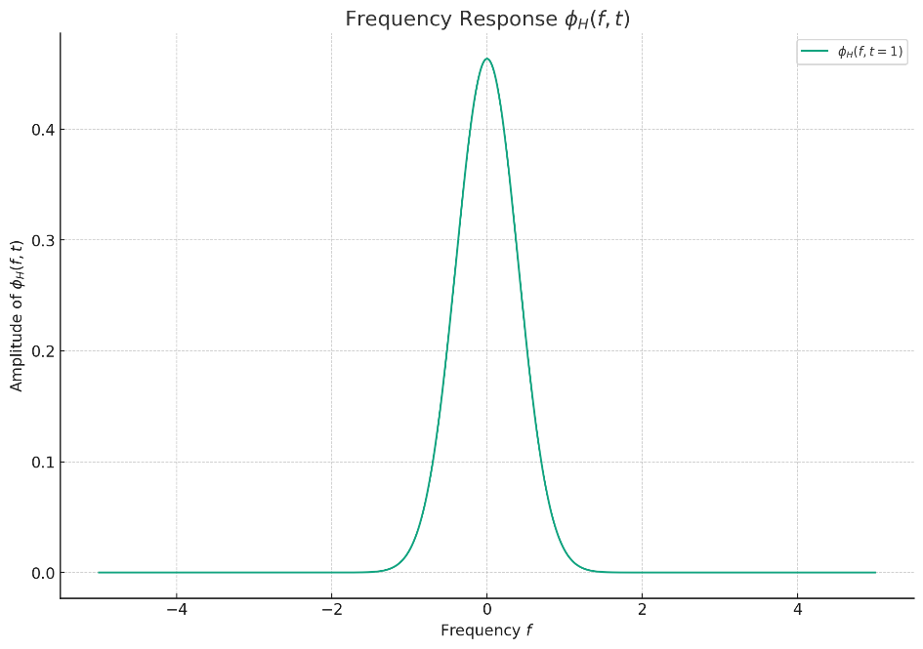

1. Consider the channel correlation function in previous problem [P4] with *n* = 5 · 10−4. Assume the channel response width is set to be at the 3 dB level from the peak. Estimate the following parameters
2. The delay spread *Tm*
3. The coherence bandwidth *Bm*
4. Verify the relationship *Bm* ≈ 1/ *Tm*
5. The coherence time *Td*
6. The Doppler bandwidth *Bd*
7. Verify the relationship *Bd* ≈ 1/ *Td*
8. 
9. 
10. 
11. 
12. 
13. 
14. Explain brieﬂy the following concepts:
15. Flat fading and frequency-selective fading
16. Slow fading and fast fading
17. Spread factor
18. Flat fading, also known as amplitude fading or non-frequency selective fading, occurs when all the frequency components of the transmitted signal experience similar fades simultaneously. It is characterized by a constant magnitude change across the signal bandwidth, which does not significantly distort the signal's frequency components. This type of fading is typically observed when the bandwidth of the signal is much smaller than the coherence bandwidth of the channel, meaning the channel has a flat response over the signal's bandwidth.

Frequency-selective fading happens when different frequency components of the transmitted signal experience different levels of fading. This occurs in channels where the signal bandwidth is larger than the channel's coherence bandwidth. As a result, parts of the signal bandwidth may fade differently, causing distortion and inter-symbol interference (ISI) in the received signal. Frequency-selective fading is common in wideband systems and environments with multipath propagation, where different paths can cause constructive and destructive interference at different frequencies.

1. Slow fading, also known as large-scale fading, is characterized by the gradual variation of the received signal's strength over long distances or time periods. It is primarily caused by obstacles in the propagation path leading to shadowing, or by the movement of the transmitter and receiver in a large-scale environment. Slow fading reflects the macroscopic changes in the signal path loss and is usually measured over tens or hundreds of wavelengths.

Fast fading, or small-scale fading, occurs over short distances or time intervals and is caused by multipath propagation effects. It results from the constructive and destructive interference of multiple signal paths varying rapidly with slight changes in the position of the transmitter, receiver, or surrounding objects. Fast fading reflects the rapid fluctuations in the amplitude and phase of the received signal, typically measured over the order of half a wavelength.

1. The spread factor, often related to spread spectrum communication techniques, quantifies the spreading of a signal's bandwidth beyond its original bandwidth for transmission. In the context of CDMA (Code Division Multiple Access) or other spread spectrum systems, the spread factor (or processing gain) is the ratio of the spread signal bandwidth to the original signal bandwidth. A higher spread factor indicates a wider signal bandwidth, which can improve the system's resistance to interference and eavesdropping, enhance privacy, and increase the capacity for multiple users in the same bandwidth. The spread factor plays a crucial role in determining the performance and robustness of spread spectrum communication systems against noise and interference.